# Project description (final)

## Factory line, surface treatment

# Global concept

The project goal is implementing a system that simulates a surface treatment process of a product (it can be anything) on an industrial factory line.

The process can be described as the following sequences : Unprocessed product will arrive from an input source (a conveyor belt), then a **mechanical arm** will load the product into a **tray**. The tray can move up and down and dive into the treatment liquid (which will be called the bath from now on). The bath regulated its temperature via a **temperature** sensor and a **resistive heater** (we assume that we want a hot liquid and not a cold liquid). When enough time has passed, the tray will move up out of the liquid and the mechanical arm will unload the process products from the tray to an output (another conveyor belt). Additionally, two sensors (**detectors**) will detect if there is any product at the end of the input conveyor, or at the beginning of the output conveyor, this way the arm will know when to load/unload.

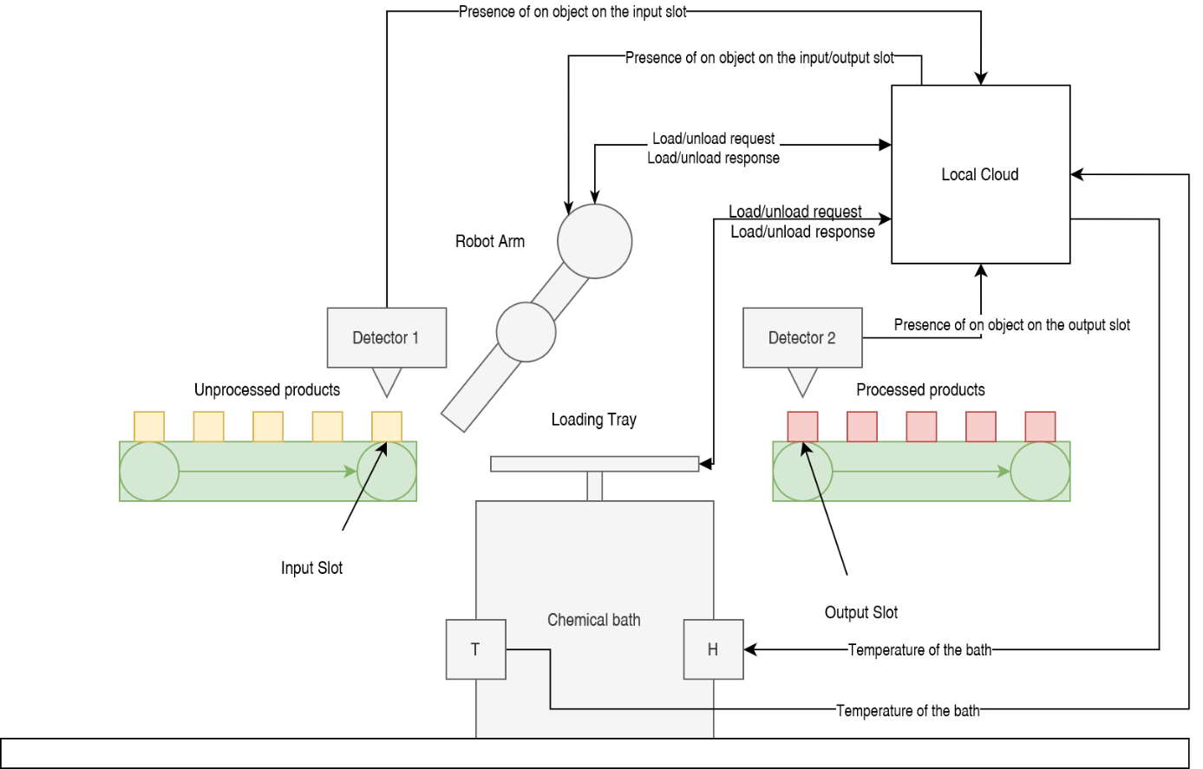The system can be schematised will the following diagram :

Figure 1 : Global system schematization

# IoT system overview

Mandator core systems :

* System registry
* Orchestrator
* System Authorization

Application systems :

|  |  |  |  |
| --- | --- | --- | --- |
| System | Type | Data/Service | Action |
| Detector 1 | Provider | Presence of a product on the input conveyor | N/A |
| Detector 2 | Provider | Presence of a product on the output conveyor | N/A |
| Temperature sensor | Provider | Temperature of the process bath | N/A |
| Arm | Provider | - Load/Unload to/from the tray | Move products |
| Consumer | - Detectors data |
| Arm | Consumer | - Arm loading/unloading | Move up and down into the bath |
| Heater | Consumer | Temperature of the process bath | Heat up the bath |

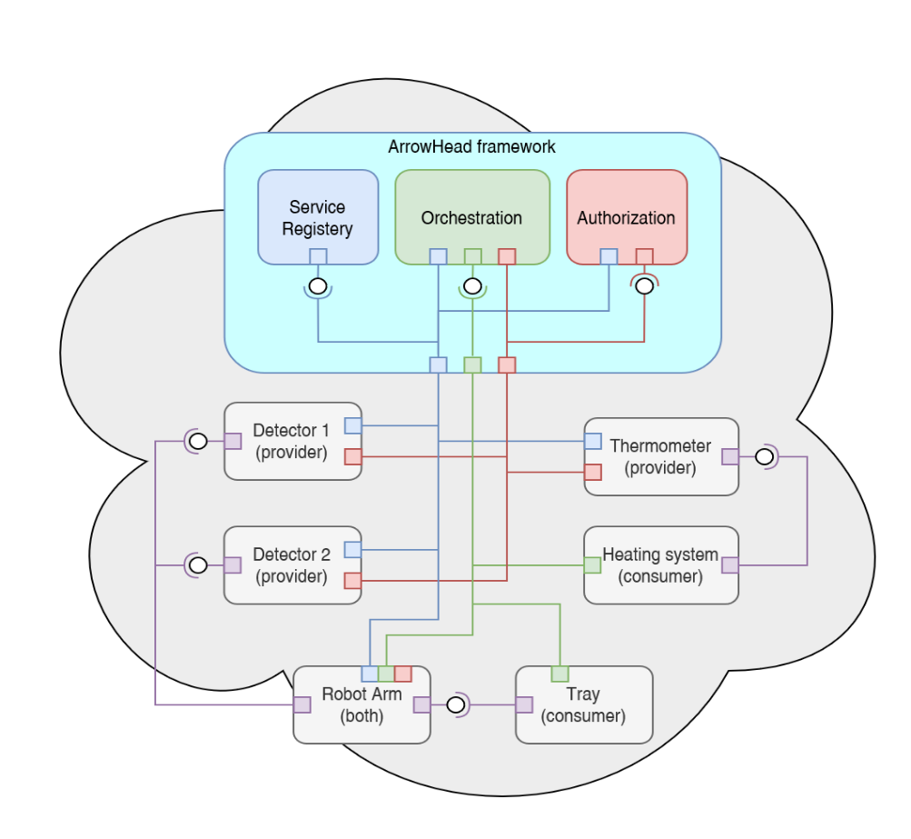Local cloud diagram :

Figure 2 : Cloud diagram